Sessions begin at 5 a.m.
From January to April -
Deneb / Antares – Direction = Going from 5 a.m. in January and ending at midnight in April
Sessions begin at 5 a.m.

From May to mid-August -
Cetus Star (Aquarius Rising / Aldebaran peak) (power for next 4 hours) - Direction = Going from 6 a.m. in May and ending at midnight in mid-August (retrograde)

Sessions begin at 5 a.m.

From September to December – Regulus - Direction = Going from 6 a.m. in September and ending at midnight in December (retrograde)

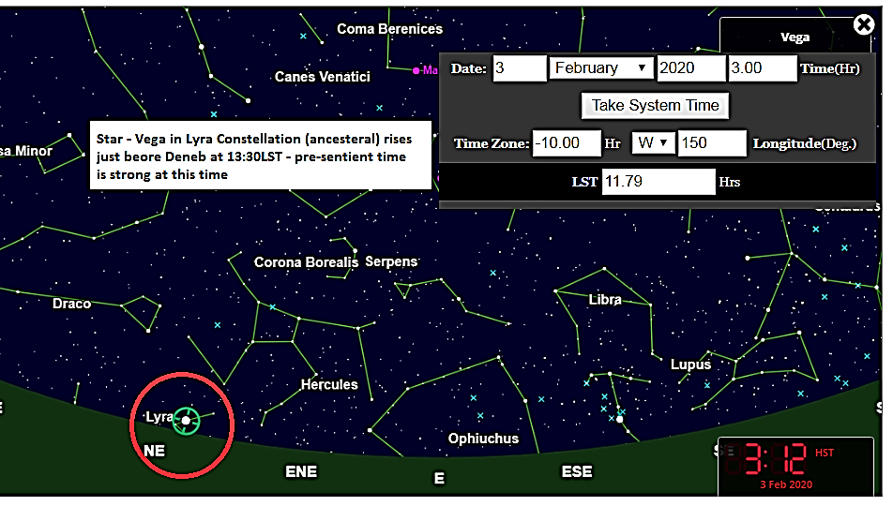
Guideline – On this date the ARV session should begin around 3:15 a.m. which is 12:09 LST
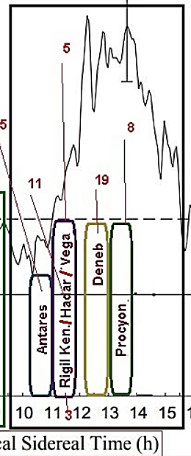
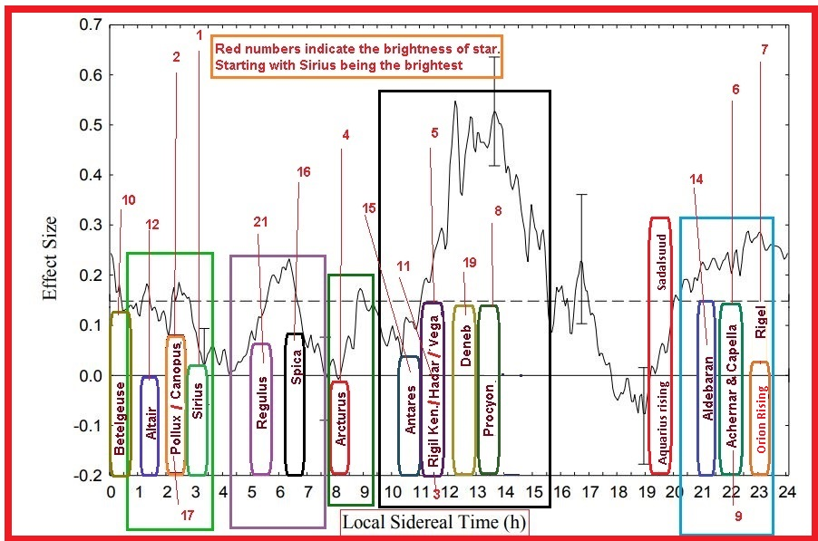

The star at the tip of Cygnus is Deneb which comes up over the east at 13:30LST

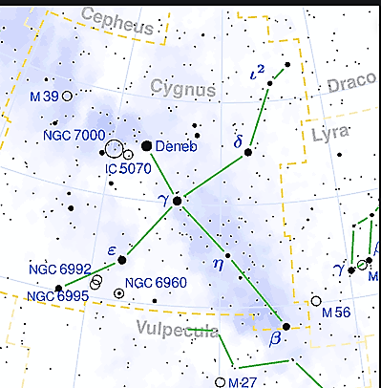
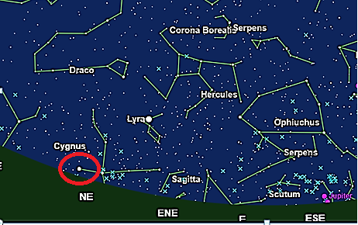

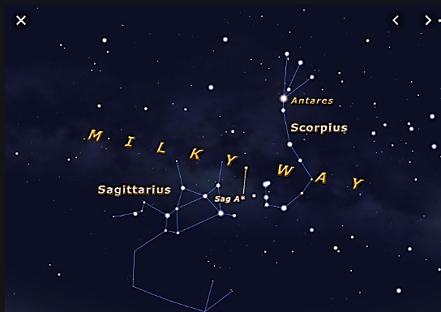
13:30LST Deneb / Cygnus
3rd January 2020 – 7 a.m.–

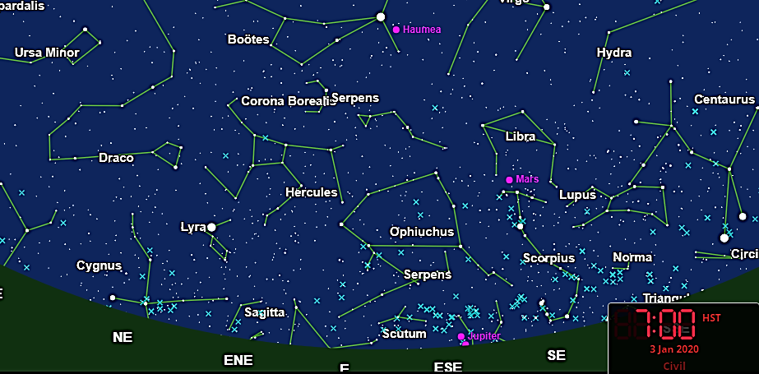
LST Time Clock Below -
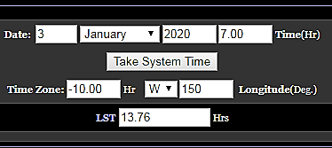
13:30LST Deneb / Cygnus
3rd January 2020 – 6 a.m.–

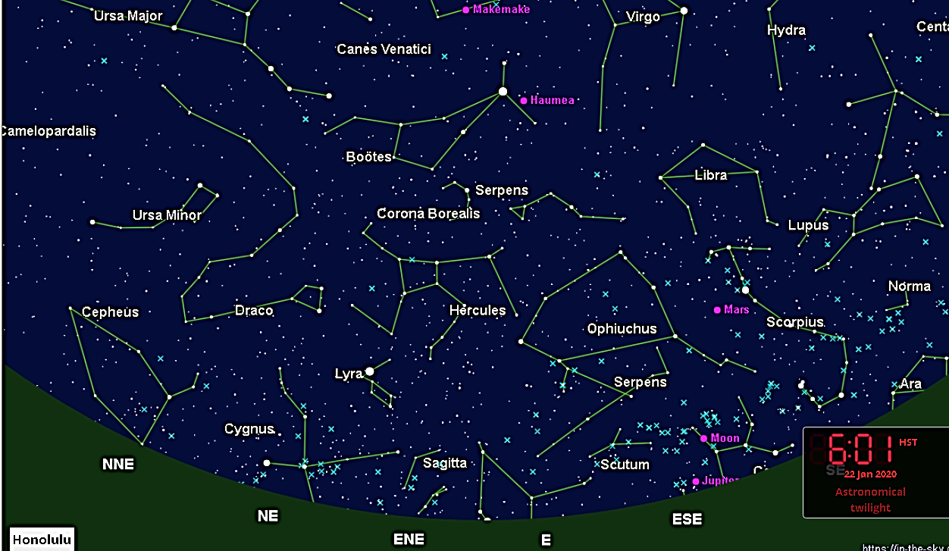

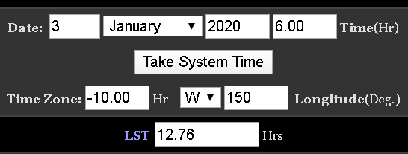

13:30LST Deneb / Cygnus
Feb 3rd, 5:00 a.m.
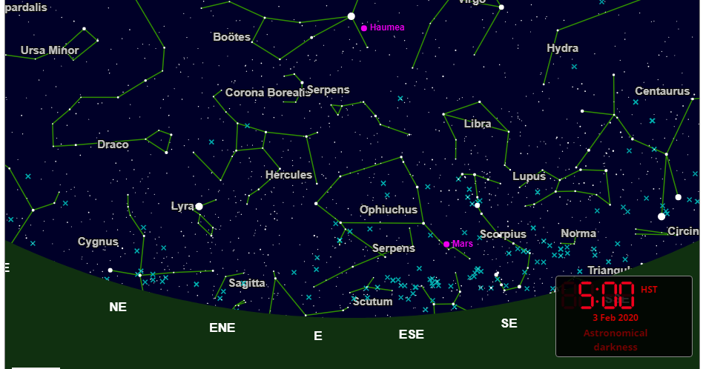
LST Time Clock Below -
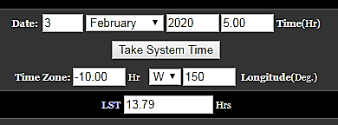

13:30LST Deneb / Cygnus
First Quarter Moon is on March 3rd, 3:00 a.m.
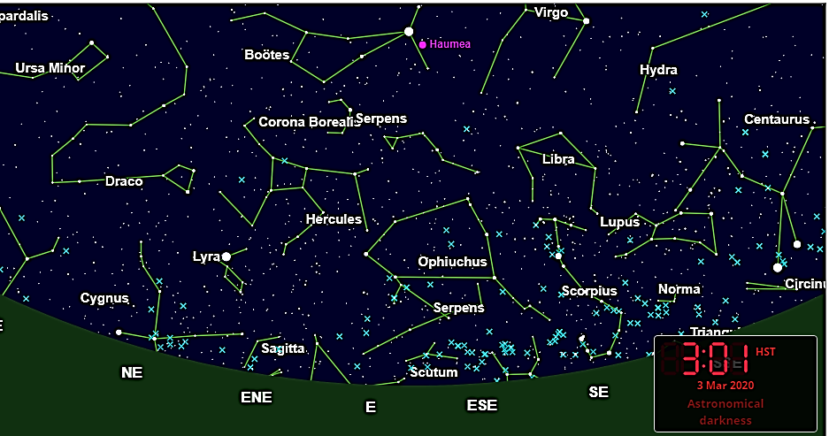
LST Time Clock Below -

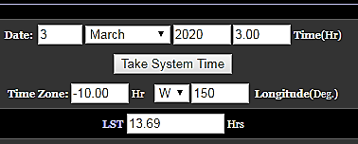

Deneb at 1 a.m. on April 3rd, 2020

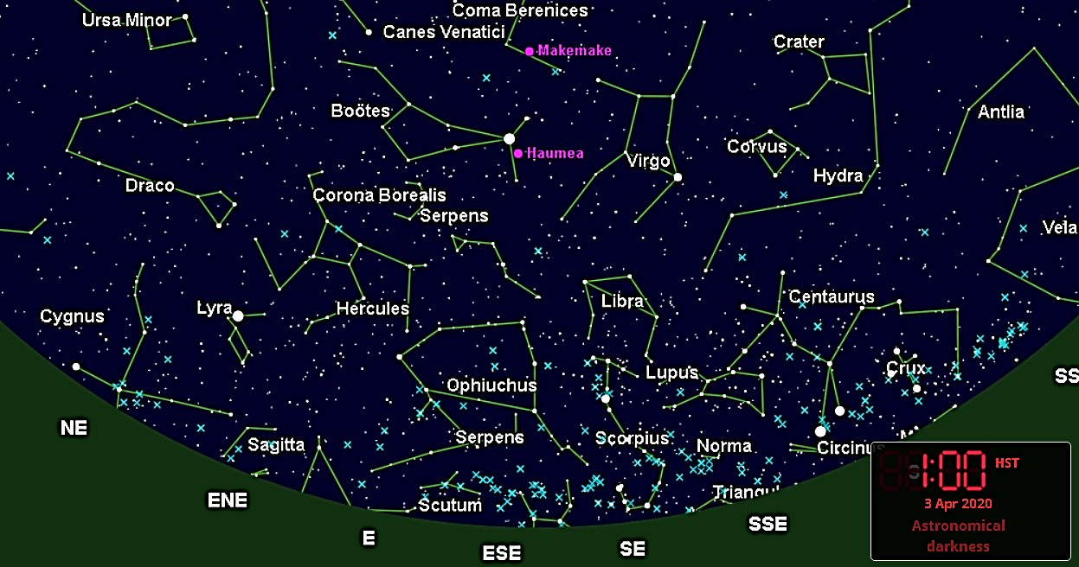

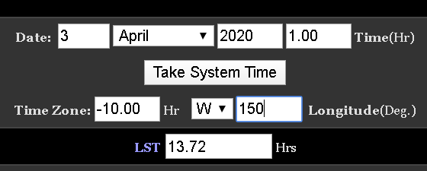

Deneb at 11:30 p.m. on April 22nd, 2020
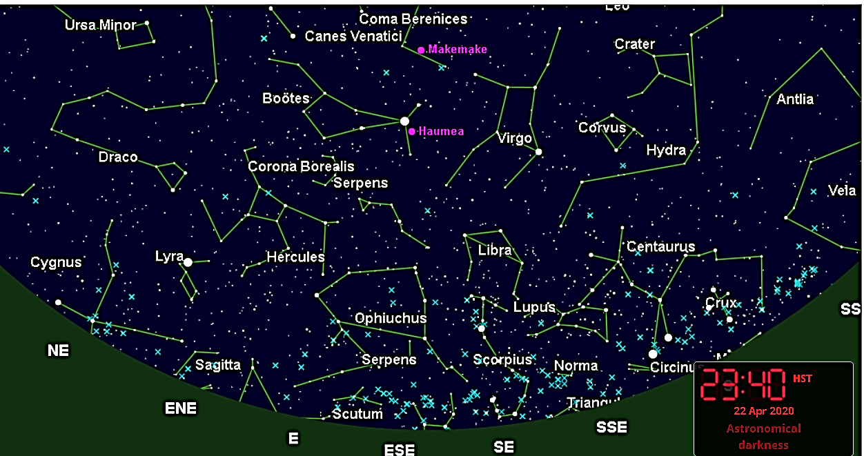
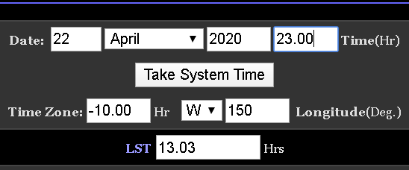

Cetus Aquarius Rising /Aldeabarn peak at 6 a.m. on May 3rd, 2020
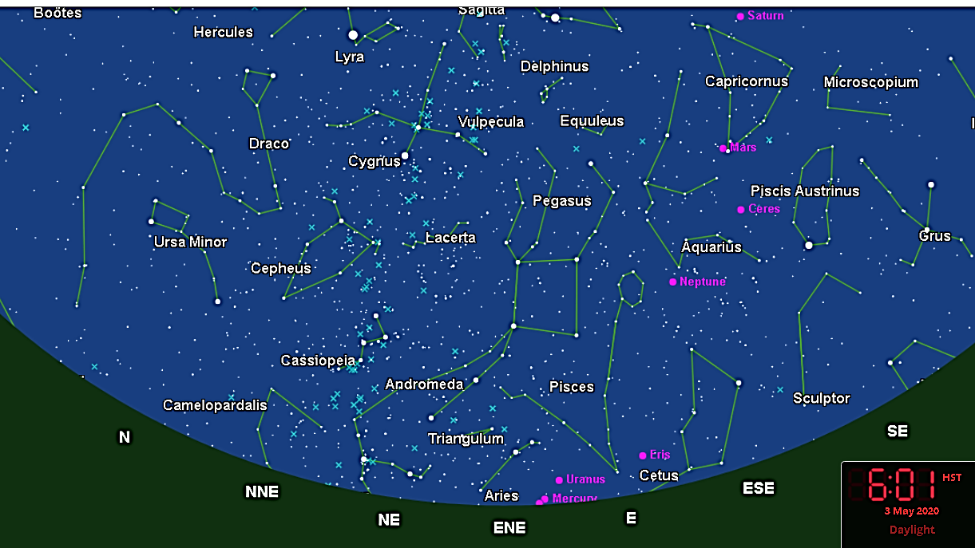

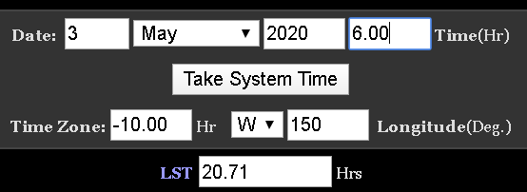

Cetus Aquarius Rising /Aldeabarn peak at 5:08 a.m.
on May 16rd, 2020

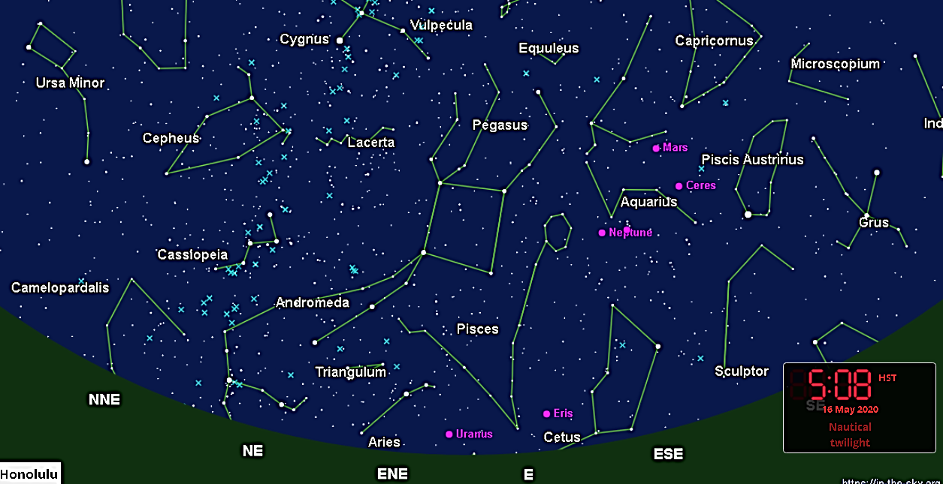
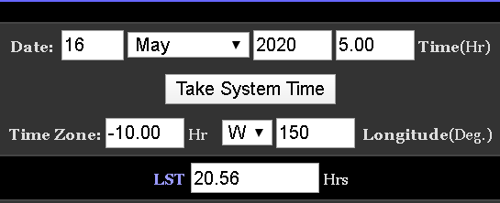

Cetus Aquarius Rising /Aldeabarn peak at 11:30 p.m. on August 15th, 2020
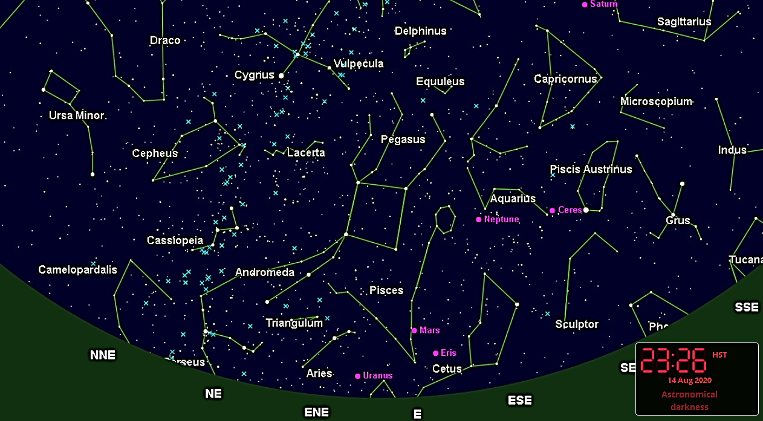

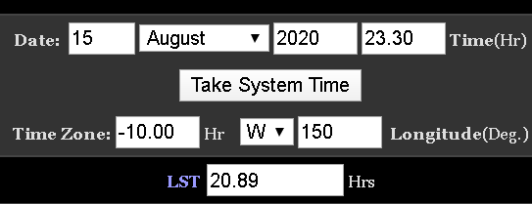

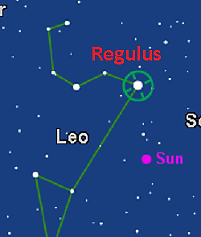

Regulus rising at 6 a.m. on September 1st , 2020

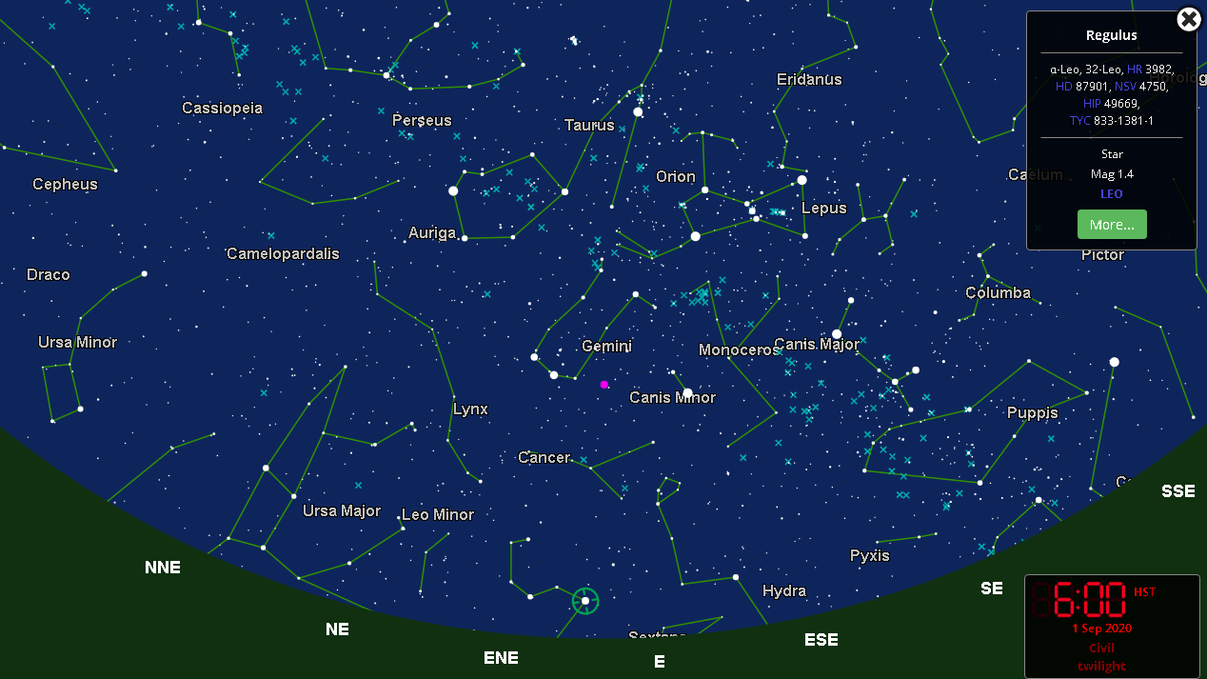

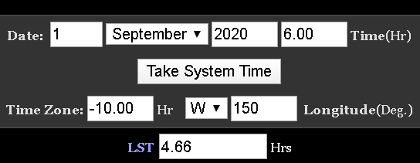

Regulus rising at midnight on December 1st , 2020
